Non-public Personal Information (NPI) Security Features
YourDox is a secure data and image archiving and delivery system designed specifically for the title industry by Pioneer Technology Group (PTG). PTG specializes in the development of secure enterprise systems for title insurance, courthouses, counties, and registers of deeds offices.
YourDox technology protects NPI in accordance with title industry best practices with:

Security of File Data and Non-public Personal Information

- All file access is password protected and accessible only by permitted employees
- System employs 256bit SSL Encryption for all transmissions
- All closing documents containing NPPI are provided via encrypted, password protected delivery

Security of Facilities
- All Data and Documents housed in SSAE16 (SOC 1) TYPE ll (formerly SAS 70) certified facility
- Data center is independently audit on annual basis and inspected daily
- All employees are subject to screening and adherence to written security policies
- Facility access controlled with biometric palm scanners, proximity card readers, and centralized
security stations
- Closed circuit video camera monitoring with 24 hour recording and 90 day video retention
Disaster Recovery Protection
- All data and documents reside in SSAE16 (SOC 1) TYPE ll (formerly SAS 70) certified facility
- Facility has parallel redundant UPS with N=1 modules and redundant AC/DC power
- All systems, including UPS, DC Power, PDU ( Power conditioning and distribution unit) HVAC,
Temperature, Humidity, Security, Fire Threat) under continuous, advanced monitoring
- Zone fire detection managed with VESDA air sampling and advanced suppression system
- Data-Grade HVAC

Audit and Oversight

- Data facility is independently audited annually and monitored continuously
- Access is restricted to approved employees and requires keycard and biometric scanning
- Facility is monitored 24 -7 – 365 by onsite staff and video monitors

Employee Screening and Training

- Background checks and criminal history checks conducted on all employees
- Staff are trained to ensure compliance with company 's information security policies
Standard Encryption Protocol
- All data, documents, and NPI in system are delivered to all parties exclusively via
256 bit SSL Encryption

Disposal and Destruction of Non-public personal information

- All Non-public Personal Information is disposed using NAID “AAA Certified” facilities and
certificates of destruction are provided.
Insurance and Licensing

- Company maintains all necessary insurances and licenses to conduct business – copies are
available at any time upon request.

800 280 5281 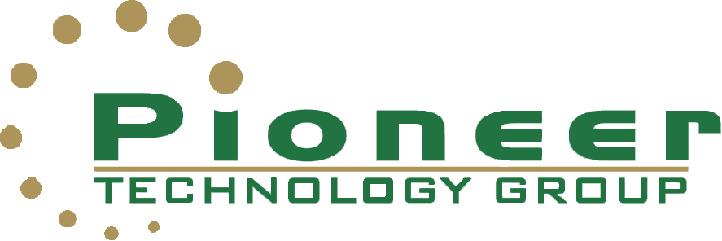 www.ptghome.com

